CP-III Project Report On

**MedGuide AI**

at

**U. V. Patel College of Engineering**



|  |  |
| --- | --- |
| **Project Guide:** | **Prepared By:** |
| Prof. Hiten Sadani | Yash Baravaliya (21012531002) |

**B.Tech Semester VII**

**(Computer Engineering-Artificial Intelligence)**

###### **November- December 2024**

Submitted to,

Department of Computer Engineering

U.V. Patel College of Engineering

Ganpat University, Ganpat Vidyanagar - 384012**U.V. PATEL COLLEGE**

**OF**

**ENGINEERING**



**07/12/24**

**CERTIFICATE**

TO WHOM SO EVER IT MAY CONCERN

This is to certify that **Mr. Yash Baravaliya** student of **B.Tech Semester VII (Computer Engineering-Artificial Intelligence)** has completed his full semester Capstone Project-III titled “**MedGuide AI**” satisfactorily in partial fulfillment of the requirement of Bachelor of Technology degree of Computer Engineering–Artificial Intelligence at Ganpat University, Ganpat Vidyanagar in the year 2024-2025.

|  |  |  |
| --- | --- | --- |
| **Prof. Hiten M Sadani** | **Dr. Paresh M. Solanki** | |
| **College Project Guide** | | **Head, Computer Engineering** |

ACKNOWLEDGEMENT

The development of MedGuide AI would not have been possible without the unwavering support, guidance, and encouragement of Prof. Hiten Sadani. His expertise and mentorship have been invaluable throughout this journey. We sincerely thank him for his insightful feedback, visionary ideas, and continuous motivation, which have been instrumental in shaping this project. We also extend our gratitude to the innovative teams at Groq and the developers behind the Gamma-7b language model, whose advanced AI technologies serve as the foundation of MedGuide AI. Our thanks go out to the open-source communities behind technologies such as Streamlit, LangChain, and FAISS. Their collaborative efforts and powerful tools have been critical to our development process. Lastly, we dedicate MedGuide AI to transforming healthcare by empowering patients, supporting medical professionals, and driving innovation at the intersection of artificial intelligence and healthcare.

With Sincere Regards from,

Mr. Yash Baravaliya

ABSTRACT

MedGuide AI is an innovative healthcare application that leverages advanced artificial intelligence technologies to revolutionize medical information access and healthcare support. Developed using Streamlit, LangChain, and powered by the Groq API with the Gamma-7b model, the application integrates five core components: an AI-powered medical chatbot, molecular generation system, medical research database, personalized physiotherapy planner, and nearby healthcare amenities locator. The system addresses critical healthcare information challenges by providing comprehensive, real-time medical insights for patients, healthcare professionals, researchers, and caregivers. By combining modern AI capabilities with extensive medical databases, MedGuide AI offers personalized, accurate, and accessible medical information, supporting evidence-based practice and enhancing healthcare decision-making. The project demonstrates the transformative potential of artificial intelligence in creating more intelligent, responsive, and user-centric healthcare information systems.

**INDEX**

**1. INTRODUCTION 1**

1.1 Problem Statement 1

1.2 Objective 1

1.3 Challenges 2

1.3.1 Challenges for Patients (Users) 2

1.3.2 Challenges for Researchers and Medical Professionals 2

1.3.3 Challenges for Platform Administrators 2

1.3.4 Challenges for Developers 2

**2. PROJECT SCOPE 4**

2.1 Literature Survey 4

2.2 Integration with Evaluation System 5

2.3 Accessibility and Inclusivity 6

2.4 Advanced Analytics and Reporting 6

2.5 Community and Support Features 6

2.6 Security and Privacy Enhancements: 7

**3. SOFTWARE REQUIREMENTS SPECIFICATIONS 8**

3.1 Technical Feasibility 8

3.2 Schedule Feasibility 9

3.3 Operational Feasibility 9

3.4 Economic Feasibility 9

**4. SOFTWARE AND HARDWARE REQUIREMENT 13**

4.1 Requirements for Developer 13

4.1.1 Hardware Requirements 13

4.1.2 Software Requirements 14

4.2 Requirements for Application User 14

4.2.1 Web Application: 14

**5. PROCESS MODEL 15**

5.1 Requirement Gathering and Analysis Phase 15

**6. PROJECT PLANNING 20**

**7. SYSTEM DESIGN 22**

7.1 Use Case Diagram 22

7.2 Activity Diagram 23

7.3 Class Diagram 24

7.4 Sequence Diagram 25

7.5 State Diagram 26

**8. IMPLEMENTATION 27**

8.2 Code of implementation 28

**9. TESTING 30**

9.1 Test Cases and Test Results 30

9.1.1 Test Cases 30

9.1.2 Test Results 30

9.1.3 Test Case: MedGuide Chat 31

9.1.4 Test Case: Molecule Generation 32

9.1.4 Additional Component Testing 32

**10. USER MANUAL 33**

10.1. Installation Steps for Developers 33

10.1.1 Install Required Software: 33

10.1.2 Steps for Developers Using the Project: 33

10.2 Installation Steps for Users: 33

10.2.1 Installation Before Using the System: 34

10.3 Steps of using the entire MedGuide AI: 34

11. CONCLUSION AND FUTURE WORK 41

**ANNEXURE 42**

**TOOLS AND TECHNOLOGY 44**

**REFERENCE 46**

LIST OF FIGURES

Figure 1 Waterfall Process Model 15

Figure 2 Gantt Chart of Entire Project Planning 20

Figure 3 Use-case Diagram 22

Figure 4 Activity Diagram 23

Figure 5 Class Diagram 24

Figure 6 Sequence Diagram 25

Figure 7 State Diagram 26

Figure 8 MedGuide AI Github Link 27

Figure 9 UI of MedGuide AI Dashboard 34

Figure 10 UI of MedGuide Chat Page-1 35

Figure 11 UI of MedGuide Chat Page-2 35

Figure 12 UI of MedGuide Chat Page-3 36

Figure 13 UI of Molecule Generation-input 36

Figure 14 UI of Molecule Generation-output 37

Figure 15 UI of Research Assistant 37

Figure 16 UI of Physio Planner 38

Figure 17 UI of Physio Planner-output 38

Figure 18 UI of personalized workout planner 39

Figure 19 UI of personalized workout planner 39

Figure 20 UI of Nearby Amenities 40

LIST OF TABLES

Table 1: Testing of Component 31

Table 2: Testing of groq API 31

Table 3: Testing of nim API 32

### INTRODUCTION

MedGuide AI is a comprehensive healthcare platform that seamlessly integrates modern medicine, pharmaceutical research, and traditional healing practices to empower patients, support medical professionals, and advance pharmaceutical innovation. Accessible via a web interface built with Streamlit and LangChain, MedGuide AI combines AI-driven solutions and cutting-edge technologies to offer an intelligent, user-centric healthcare experience.  
Key features include an AI-powered chatbot for medical advice, tools for molecule generation to aid pharmaceutical research, tailored physiotherapy planning, access to nearby medical amenities, and integration with medical research databases for evidence-based recommendations. A FAISS-based database ensures fast and efficient information retrieval, while the Gamma-7b model accessed via the Groq API guarantees accurate and reliable recommendations. By bridging gaps between patients, healthcare professionals, and researchers, MedGuide AI aims to create a healthier and more informed society.

1.1 Problem Statement

Access to accurate medical information, efficient drug discovery, personalized healthcare planning, and reliable local resources often remains a challenge. Patients face difficulties in obtaining timely medical advice and tailored health plans, while researchers and professionals encounter roadblocks in innovation due to limited resources. The lack of comprehensive platforms combining modern medicine, traditional healing, and advanced AI tools exacerbates these issues.

1.2 Objective

MedGuide AI seeks to revolutionize he**No table of figures entries found.**althcare by providing:

* **Accurate Medical Recommendations**: Utilizing Groq API and Gamma-7b for real-time, AI-driven medical advice.
* **Efficient Drug Development**: Enabling molecule generation for pharmaceutical innovations.
* **Personalized Care Plans**: Tailoring physiotherapy and rehabilitation strategies to individual needs.
* **Convenient Access to Resources**: Offering location-based recommendations for nearby medical amenities.
* **Research Integration**: Ensuring access to up-to-date medical literature for professionals and students.
  1. Challenges

This section outlines the difficulties faced by patients, counsellors, platform administrators and developers in managing and maintaining MedGuide AI

* + 1. Challenges for Patients (Users)

Limited Medical Knowledge: Difficulty accessing accurate and trustworthy information about medicines and health conditions.

Delayed Diagnosis: Lack of immediate assistance for queries or symptoms due to limited availability of medical professionals.

Personalized Care: Challenges in finding healthcare plans tailored to specific needs and conditions.

Healthcare Navigation: Difficulty locating nearby amenities like pharmacies and clinics with relevant services.

1.3.2 Challenges for Researchers and Medical Professionals

Researchers and medical professionals face significant challenges when managing the complexities of vast molecular and medical data. Interpreting these large datasets requires sophisticated tools and methodologies, often under time constraints that limit the ability to thoroughly analyze patient information or research findings. Access to consolidated and verified medical literature remains fragmented, making real-time decision-making and evidence-based practices difficult. The need for tools that simplify and streamline these processes is critical for enabling more efficient research and clinical applications.

1.3.3 Challenges for Platform Administrators

Platform administrators encounter numerous hurdles in maintaining a robust and efficient system like MedGuide AI. Managing and synchronizing the FAISS database with the latest medical data demands meticulous oversight to ensure relevance and accuracy. Ensuring the platform’s privacy and security is another key challenge, requiring advanced encryption methods to safeguard sensitive medical and user information. Administrators also face the responsibility of maintaining seamless uptime and functionality across all system components to provide an uninterrupted user experience.

1.3.4 Challenges for Developers

Developers of MedGuide AI must address the complexities of implementing advanced features such as AI-powered chatbots, molecular structure generation, and personalized physiotherapy planners. Integrating real-time functionality with third-party APIs, like the Groq API, and external databases, such as PubMed, adds to the technical complexity. Building a scalable platform capable of handling an expanding user base and evolving medical needs is a continuous challenge. Additionally, developers must ensure cross-platform compatibility to deliver a uniform and user-friendly experience across diverse devices and interfaces.

### PROJECT SCOPE

The initial scope of **MedGuide AI** focuses on developing a comprehensive healthcare platform that integrates modern medicine, pharmaceutical research, and traditional healing practices. The platform is designed to provide users with accessible, personalized, and innovative solutions for managing their healthcare needs. The core features include:

* **MedGuide Chat**: An AI-powered chatbot using the Gamma-7b model via the Groq API to provide accurate information on medicines, their composition, usage, and side effects.
* **Molecule Generation**: Tools for AI-driven molecular generation to aid in pharmaceutical research and drug discovery.
* **Research Integration**: Access to verified medical literature through integration with PubMed and other databases.
* **Physio Planner**: AI-driven, personalized physiotherapy recommendations based on individual user profiles.
* **Nearby Amenities**: Tools to locate and provide information about nearby healthcare facilities, pharmacies, and medical resources.

To further enhance the platform's impact and user experience, MedGuide AI will explore the following areas of expansion:

2.1 Literature Survey

The field of healthcare has witnessed significant advancements with the integration of artificial intelligence (AI), enabling solutions that bridge gaps in accessibility, personalization, and efficiency. MedGuide AI is positioned at the intersection of modern medicine, pharmaceutical innovation, and traditional healing practices. This literature survey evaluates existing healthcare technologies, identifies gaps, and highlights the unique contributions of MedGuide AI.

2.1.1 AI in Healthcare and Chatbots:

AI-powered healthcare systems, especially chatbots, have been revolutionizing how patients access medical information[11]. By utilizing AI models such as GPT-based systems, companies have significantly improved the way patients receive medication details, side effects, and more ​[10] Chatbots enable real-time, accurate, and reliable access to medical data, providing a 24/7 service to patients, reducing human error, and enhancing the efficiency of healthcare professionals' interactions with patients.

2.1.2 AI in Drug Discovery and Molecule Generation:

AI-driven tools, including generative algorithms and deep learning models, are at the forefront of accelerating drug discovery [10] Companies such as Insilico Medicine and Iktos are using AI for de novo drug design, where the models generate novel molecules for disease treatment [[11]](https://www.azolifesciences.com/news/20240712/Artificial-Intelligence-Drives-Breakthroughs-in-Drug-Discovery-Reducing-Costs-and-Timelines.aspx) These AI systems utilize large datasets to predict molecular properties and optimize compounds, greatly reducing the time and cost of developing new drugs. For MedGuide AI, integrating AI for molecule generation can support researchers by providing accurate SMILES notation for compounds, thus enhancing drug development processes.

2.1.3 AI in Research Integration:

The use of AI to process and present research findings has made accessing medical research databases like PubMed more efficient. AI-powered systems can sift through large volumes of medical literature, extracting key insights that are useful for researchers, clinicians, and students [10] For MedGuide AI, leveraging AI to aggregate research findings can significantly aid in evidence-based practices, supporting continuous learning and the integration of new medical knowledge.

2.1.4 Generative AI for Drug Design:

The application of generative AI to accelerate drug development has seen success stories such as Insilico Medicine’s AI-designed anti-fibrotic small molecule inhibitor, which is currently in clinical trials [10] The ability to rapidly design and test drug candidates is poised to transform how the pharmaceutical industry approaches drug research, making AI a powerful tool for speeding up time-to-market and improving clinical outcomes.

These advancements can serve as a foundation for the development of MedGuide AI, which aims to bring together modern medicine, AI, and research to improve patient care, accelerate pharmaceutical innovation, and offer personalized health recommendations.

2.2 Integration with Evaluation System

MedGuide AI will integrate advanced evaluation mechanisms to measure the effectiveness of its features and monitor user outcomes. Key initiatives include:

* **Performance Metrics**: Tracking user engagement, health improvements, and adherence to recommendations.
* **Feedback Loops**: Incorporating user and professional feedback to refine features.
* **Outcome Reports**: Providing detailed reports for medical professionals, researchers, and patients to analyze long-term healthcare outcomes.
* **Interoperability**: Ensuring compatibility with tools and systems used by healthcare professionals for broader analysis and assessments.

2.3 Accessibility and Inclusivity

The platform will ensure equitable access by incorporating features to cater to diverse audiences:

* **Assistive Technologies**: Support for screen readers, text-to-speech, and voice commands for users with disabilities.
* **Multilingual Support**: Making the platform available in multiple languages to reach a global audience.
* **Cultural Sensitivity**: Designing features to accommodate cultural nuances in healthcare practices and patient needs.
* **Universal Design Principles**: Ensuring accessibility for users with physical, cognitive, and learning disabilities.

2.4 Advanced Analytics and Reporting

MedGuide AI will leverage advanced analytics to provide actionable insights:

* **Real-Time Monitoring**: Enabling real-time data visualization of user health patterns and engagement.
* **Predictive Analytics**: Identifying health risks and enabling early intervention through AI-driven insights.
* **Custom Dashboards**: Creating customizable dashboards for healthcare providers to access user data and trends.
* **Research Insights**: Generating data to support ongoing pharmaceutical and medical research.

2.5 Community and Support Features.

MedGuide AI aims to create a collaborative healthcare ecosystem with the following features:

* **Community Forums**: Platforms for users to share experiences and seek peer support.
* **Educational Resources**: Access to webinars, workshops, and content curated by healthcare experts.
* **Gamification**: Introducing challenges, rewards, and badges to motivate user engagement.
* **Resource Sharing**: Tools for sharing self-care tips, health articles, and podcasts within the community.

2.6 Security and Privacy Enhancements:

Data security and privacy are central to MedGuide AI’s mission. Planned initiatives include:

* **End-to-End Encryption**: Securing all communications and stored data.
* **Role-Based Access Control**: Restricting access to sensitive information to authorized personnel only.
* **Regular Audits**: Conducting periodic security assessments to identify vulnerabilities.
* **Transparent Policies**: Educating users on data collection, usage, and protection measures.
* **Incident Response Plan**: Establishing protocols to mitigate and address potential security breaches effectively.

By focusing on these areas, MedGuide AI aims to continually evolve into a robust, user-friendly, and impactful healthcare platform that meets the diverse needs of patients, professionals, and researchers alike.

### SOFTWARE REQUIREMENTS SPECIFICATIONS

The feasibility analysis of MedGuide AI involves assessing its technical, economic, and operational feasibility. Below are the findings:

3.1 Technical Feasibility

MedGuide AI integrates multiple advanced technologies to deliver its core functionalities. The platform is accessible through a streamlined web interface and incorporates modules like MedGuide Chat for AI-driven medical assistance, Molecule Generation for pharmaceutical research, Research integration for evidence-based information, Physio Planner for personalized physiotherapy guidance, and Nearby Amenities to connect users with local healthcare resources.

The technical feasibility of MedGuide AI involves assessing the hardware, software, and integration capabilities required to ensure the system's optimal performance. The system’s backbone includes a robust tech stack, combining Streamlit for the frontend interface, LangChain for workflow orchestration, and FAISS for efficient database retrieval. The Gamma-7b model accessed via the Groq API forms the AI layer, delivering accurate and context-aware responses across the platform. In addition, the secure integration of data sources like PubMed ensures that the system remains up-to-date with the latest medical research.

**3.1.1 The Human and Economic Factors**

1. **Human Factor**: A development team of experienced frontend and backend developers, AI/ML specialists, and database engineers. Collaboration with medical professionals ensures reliable and user-friendly content.
2. **Economic Factor**: Key costs include development tools, cloud hosting, and Groq API [7] integration for the Gamma-7b model. Revenue is expected from user subscriptions, partnerships with healthcare providers, and system scalability.

**3.1.2 Possible Solutions to the Problems**

1. **Efficient Tech Stack**: Use Streamlit for the frontend, LangChain for orchestration, and FAISS for data retrieval.
2. **Groq Integration:** Leverage the Gamma-7b model for accurate and context-aware responses in various modules.
3. **Security Measures**: Implement secure APIs, and strict data access protocols to safeguard user information.

This comprehensive assessment ensures that MedGuideAI is both technically feasible and capable of delivering its intended functionalities effectively.

**3.2 Schedule Feasibility**

The development of MedGuide AI follows a phased approach to ensure timely delivery and continuous enhancement of features. The first phase focuses on building a Minimum Viable Product (MVP) with core functionalities such as MedGuide Chat, Molecule Generation, and Nearby Amenities. These features are prioritized to establish a strong foundation for the platform and address the most critical user needs.

Subsequent phases will introduce advanced modules like Physio Planner and enhanced research integration, leveraging user feedback to refine and expand the system. The development timeline is estimated to span approximately four months for the MVP, with iterative updates and feature additions continuing beyond the initial launch. This phased approach ensures that the platform remains adaptable to changing user needs and technological advancements.

3.3 Operational Feasibility

MedGuide AI is designed to operate efficiently and reliably, meeting the diverse needs of patients, healthcare professionals, and researchers. The platform features a user-friendly interface that caters to individuals with varying levels of technical expertise, ensuring accessibility for all users. The AI-powered MedGuide Chat provides 24/7 support, delivering accurate medical advice, medication details, and healthcare recommendations.

Scalability is a key operational consideration, with the platform’s architecture optimized to accommodate a growing user base. The use of cloud-based hosting and an efficient FAISS database ensures that the system can handle large volumes of concurrent users without compromising performance. Additionally, the continuous integration of user feedback into the Physio Planner and other modules enhances the platform’s ability to deliver personalized and effective healthcare solutions.

3.4 Economic Feasibility

Economic feasibility for **MedGuideAI** involves evaluating the expected benefits and savings of the system in relation to its costs. This cost/benefit analysis helps determine if the system provides enough value to justify its development and implementation.

* **Cost- based study:** It is important to identify cost and benefit factors, which can be categorized as follows:

1. **Development Costs**: Streamlit and LangChain-based UI, Groq API [7] subscription, and model training.
2. **Operational Costs**: FAISS database maintenance, hosting fees, and periodic updates.

* **Time-based study:** This focuses on the time required to achieve a return on investment, considering how quickly the platform will become viable and generate value for users. The future value of the platform also plays a role in assessing its long-term impact and sustainability.

**3.5 Functional Requirements**

Functional requirements (FRs) are a type of software requirements that specify the functions or features a system must have to meet the intended purpose and objectives. These requirements describe what the system is supposed to do in terms of its functionality. Functional requirements are typically documented in a software requirements specification (SRS) and serve as a foundation for the design and development of the system. Functional Requirements are mentioned below for the project MedGuide AI.

**3.5.1 User Authentication and Authorization**

MedGuide AI ensures secure access through user registration and role-based access control. Patients, healthcare professionals, and administrators can register using secure protocols, and role-specific permissions restrict access to sensitive data.

**3.5.2 MedGuide Chat**

Powered by the Gamma-7b model, MedGuide Chat provides instant and accurate responses to medical queries. The integration with FAISS ensures that users receive up-to-date and contextually relevant information about medications, side effects, and treatment options.

* **Groq-Powered Chatbot:** Provides accurate medication advice, side effects, and composition details.
* **Integration with FAISS DB:** Enables quick access to up-to-date medical data.

**3.5.3 Molecule Generation**

This module supports pharmaceutical research by generating SMILES notations for chemical compounds. Researchers can input compound names and receive AI-generated molecular structures, accelerating drug discovery and development processes.

* **SMILES Generation:** Generate compound notations using AI-driven algorithms.
* **Drug Discovery Support:** Assist researchers with rapid prototyping of molecular structures.

**3.5.4 Research Module**

MedGuide AI integrates with medical research databases like PubMed to provide evidence-based information. The AI-powered search and summarization capabilities help users quickly access and understand relevant research findings.

* **Medical Database Integration:** Seamlessly connect with PubMed and other repositories.
* **Evidence-Based Results:** AI-powered summaries for researchers and medical professionals.

**3.5.5 Physio Planner**

The Physio Planner offers tailored exercise recommendations based on user profiles and health conditions. The system incorporates user feedback and medical expertise to continuously refine and improve its recommendations.

* **Customized Plans:** Tailored exercises based on user health profiles.
* **Feedback Integration:** Continuously improve recommendations via user feedback.

**3.5.6 Nearby Amenities**

This feature connects users with local healthcare resources, such as hospitals and pharmacies, providing detailed information about their location, services, and operating hours.

* **Location-Based Search:** Find nearby hospitals, pharmacies, and wellness centers.
* **MedGuide Chat Integration:** Instant access to amenity information through chat.

**3.6 Non-Functional Requirements**

Non-functional requirements specify the system's performance, security, and usability standards. For **MedGuideAI**, these include ensuring fast response times, high availability, and robust data security. They ensure the system meets user expectations for reliability and efficiency.

**3.6.1 Performance Requirements**

* **Response Time**: Chatbot responses within 2 seconds under normal load.
* **Scalability**: The platform might support up to 10,000 concurrent users without performance degradation.

**3.7 Security Requirements**

Security requirements for MedGuideAI are described below:

**3.7.1 Data Transfer**

* All sensitive data transfers, such as login credentials and health data, must use end-to-end encryption (e.g., SSL/TLS). In MedGuideAI Hashing encryption is used for Vector storing.
* Cookies do not store sensitive information, like passwords, to prevent unauthorized access.

**3.7.2 Data Storage**

* Health info shall be stored securely using hashing algorithms (e.g., bcrypt).
* Only authenticated administrators can access sensitive system-level data or configurations. For this we have used Firebase.

**3.8 Software Quality Attributes**

MedGuide AI ensures high availability, with a 99.9% uptime guarantee, and is built to be maintainable and fault-tolerant. Regular backups and quick recovery mechanisms minimize downtime, while user feedback continuously informs system improvements.

### SOFTWARE AND HARDWARE REQUIREMENT

System requirements refer to the minimum specifications and configurations that a computer system must have to run a particular software application, operating system, or hardware device effectively. These requirements ensure that users have a satisfactory experience and optimal performance when using the MedGuideAI.

4.1 Requirements for Developer

Developers need access to integrated development environments (IDEs), version control systems, and relevant programming languages to efficiently write, test, and debug code. Additionally, collaboration tools and documentation resources are essential for effective communication and streamlined development workflows.

4.1.1 Hardware Requirements

Developers working on MedGuide AI need reliable hardware with sufficient computing power to manage resource-intensive tasks, such as AI model training and database management. The recommended hardware specifications include:

* **Development Machines:**
  + Processor: Intel i7 or AMD Ryzen 7 (or higher)
  + Memory: 16 GB RAM or higher
  + Storage: 500 GB SSD (Solid State Drive) or higher
  + Graphics: Dedicated GPU with at least 4 GB VRAM for machine learning tasks
  + Display: Full HD monitor or better
* **Server Requirements:**
  + **Processor:** Multi-core CPU (Xeon or equivalent)
  + **Memory:** Minimum 32 GB RAM
  + **Storage:** 1 TB SSD with RAID configuration for data redundancy
  + **Network:** Gigabit Ethernet for high-speed connectivity

4.1.2 Software Requirements

Developers need specialized software tools to build and manage MedGuide AI efficiently. The recommended software stack includes:

• **Integrated Development Environment (IDE):** Visual Studio Code, PyCharm, or Jupyter Notebook

• **Programming Languages:** Python 3.9+

• **Backend Framework:** Flask for APIs and LangChain for workflow orchestration

• **Database Management:** FAISS for vector storage

• **Version Control System:** Git with GitHub or GitLab for code collaboration

• **AI/ML Libraries:** TensorFlow, PyTorch, and Hugging Face transformers for model development

4.2 Requirements for Application User

End users of MedGuide AI, including patients, healthcare providers, and researchers, require devices and software environments compatible with the platform to ensure a smooth and engaging experience.

4.2.1 Web Application:

* **Browser:** Modern browsers like Chrome, Firefox, Edge, or Safari (latest versions)
* **JavaScript Enabled:** Required for dynamic interactions on the website
* **User Account:** A verified user account for authentication and personalized features

MedGuide AI’s architecture ensures compatibility with a wide range of devices, enabling easy access for users while maintaining robust performance across platforms. These hardware and software requirements form the foundation for delivering a high-quality healthcare experience.

### 5. PROCESS MODEL

The Process Model we used in this project is Waterfall model. We use this model because of our project flow match with this model among all the models of software engineering. Waterfall Model (Figure 1) is a classical software development methodology that was first introduced by Winston W. Royce in 1970. It is a linear and sequential approach to software development that consists of several phases that must be completed in a specific order. The phases include:

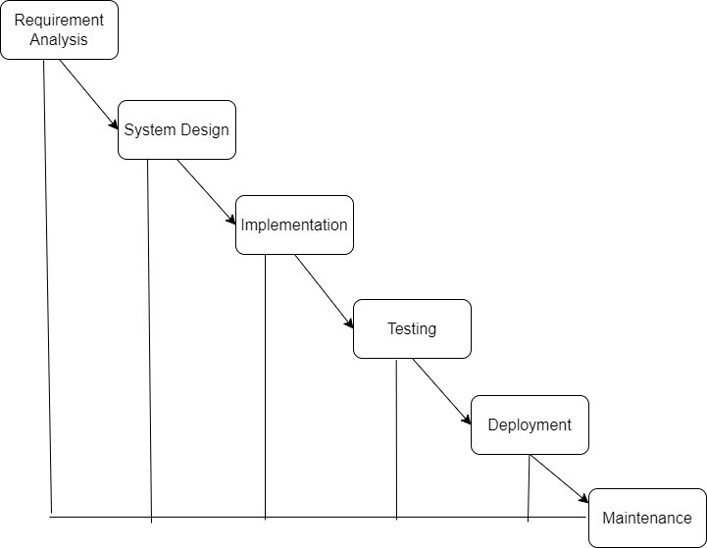

Figure 1 Waterfall Process Model

5.1 Requirement Gathering and Analysis Phase

The **Requirement Gathering and Analysis Phase** is essential for defining the scope and objectives of the **MedGuideAI** project. This phase focuses on understanding the needs of various stakeholders, including mental health professionals, patients, and administrators, while also incorporating insights gathered through research and competitive analysis.

**Activities in this Phase:**

All the activities involved this phase for proper and seamless development process are listed below:

5.1.1 Identifying Stakeholders

Key stakeholders for **MedGuide AI** include patients, healthcare providers, pharmaceutical researchers, traditional healing practitioners, administrators, the development team, and regulatory authorities. Collaborating with these stakeholders ensures the platform meets diverse user needs, adheres to medical and legal regulations, and remains innovative and efficient. Investors and strategic partners also play a critical role in scaling and supporting MedGuide AI's development and deployment.

5.1.2 Methods for Gathering Requirements

To ensure the development of MedGuide AI aligns with user and stakeholder needs, the following methods are employed:

* 1. **Interviews:** Conduct interviews with doctors, pharmacists, patients, and researchers to identify pain points, user preferences, and gaps in existing solutions.
  2. **Surveys and Focus Groups:** Collect feedback from patients and healthcare professionals regarding expectations from digital healthcare platforms.
  3. **Observations:** Study user interactions with existing healthcare platforms to identify usability challenges and improvement areas.
  4. **Competitive Analysis:** Analyze competitors in the healthcare technology domain to benchmark features and identify opportunities for differentiation.

**5.1.3 Prioritization and Validation**

The prioritization and validation phase focuses on ensuring that the documented requirements align with the project's objectives and stakeholder expectations. Requirements are ranked based on their impact on stakeholders, technical feasibility, and business value to determine their importance and implementation sequence. Validation involves close collaboration with stakeholders to review, refine, and finalize the requirements, ensuring they are practical, clear, and aligned with the project’s goals. This phase lays the groundwork for a smooth transition into the design phase by solidifying the project's scope and priorities.

**5.1.4 Output:**

The outputs of this phase provide a comprehensive foundation for subsequent stages of development. They include well-defined project goals, a clear scope of work, and measurable success criteria to guide the project. Risk analysis is performed to identify potential challenges, along with strategies to mitigate them. Finally, the requirements are documented and approved, ensuring the team is ready to proceed confidently into the design phase.

**5.2 Design Phase**

Design Phase outlines the blueprint for MedGuide AI’s architecture, user interfaces, and core components.

**5.2.1 System Architecture Design**

MedGuide AI’s architecture includes the following layers:

* **Presentation Layer:** Design user interfaces for the web app, mobile app, and MedGuide Chat.
* **Business Logic Layer:** Develop logic for medicine recommendations, molecule generation, and physio planning.
* **Data Access Layer:** Establish mechanisms for accessing and storing data securely.
* **Database Layer:** Establish databases for medicine data, user records, and molecular research.

**5.2.2 User Interface Design**

Design tailored dashboards for each user type:

1. **Admin Dashboard:** Monitor system performance and data usage.
2. **Healthcare Provider Dashboard:**
   1. Access patient insights and medical history.
   2. Collaborate on research and provide recommendations
3. **Patient Dashboard:**
   1. Book consultations and receive personalized medicine suggestions.
   2. Track health metrics and interact with MedGuide Chat.

**5.2.3 Wireframing and Prototyping**

It is show the wirefame of the prototype

* Create wireframes for all dashboards and the chatbot interface.
* Develop interactive prototypes to test usability.
* Tools: Use Figma, Adobe XD, or similar platforms.

**5.2.5 Component Design**

* **Reusable Components:** Create elements like buttons, forms, and dashboards for reuse.
* **Backend Services:** Develop APIs for functionalities like medicine recommendations, chatbots, and molecule generation.
* **Modules:** Break the system into core modules such as authentication, data retrieval, and AI-based suggestions.

**5.2.6 Integration Design**

* **External APIs:** Plan integrations for drug databases, research repositories, and health trackers.
* **Internal APIs:** Enable communication between MedGuide Chat, FAISS database, and other modules.

**5.2.7 User Experience (UX) Design**

* **User Flow:** Define user journeys for patients and professionals.
* **Accessibility:** Ensure compliance with accessibility standards.
* **Feedback Mechanisms:** Design feedback tools for users to report issues or suggest improvements.

**5.3 Implementation**

MedGuide AI is developed to bridge modern and traditional healthcare practices:

* **Admins:** Manage platform operations and onboard professionals.
* **Healthcare Providers:** Offer personalized medical advice and contribute to research initiatives.
* **Patients:** Access medical recommendations, locate nearby amenities, and interact with the AI chatbot for queries..

**5.4 Testing**

The **Testing Phase** ensures MedGuideAI is functional and reliable:

* **Functional Testing:** Validate medicine recommendation, molecule generation, and chatbot interaction modules.
* **Integration Testing:** Test inter-module communication and external API integrations.
* **User Acceptance Testing (UAT):** Gather feedback from stakeholders to ensure usability.
* **Iterative Refinement:** Address defects and improve features incrementally.

**5.5 Deployment**

MedGuide AI is deployed on **Render** for scalability and cost efficiency. The platform supports web, mobile, and chatbot interfaces, with a backend hosted on scalable infrastructure. The FAISS database ensures fast and secure data retrieval, while real-time monitoring and updates guarantee reliable performance. The deployment ensures high availability and seamless performance across platforms, with built-in monitoring and security features to guarantee smooth user experiences and secure data management. This approach allows MedGuide AI to efficiently scale and serve its growing user base while maintaining a reliable service.

**5.6 Maintenance**

The **Maintenance Phase** ensures the platform continues to meet evolving needs:

* Fixing post-deployment issues.
* Incorporating user feedback for feature enhancements.
* Regular updates for security and performance.

### 6. PROJECT PLANNING

Effective project planning is critical for the successful development and implementation of **MedGuide AI**, ensuring timely delivery, efficient resource management, and meeting user expectations. The Gantt Chart (Figure 2) of the MedGuide AI Project Plan illustrates the comprehensive timeline of the project, detailing five main phases: **Requirement Gathering, System Design, Development, Testing, and Deployment**. The **Requirement Gathering Phase** involves stakeholder engagement, user surveys, and competitive analysis to identify user needs and define project goals. The **System Design Phase** includes Interface Design, Database Design, and the creation of System Architecture Diagrams, forming the blueprint for the application. During the **Development Phase**, the team focuses on backend development (e.g., APIs for medicine recommendations and molecule generation) and frontend implementation using frameworks like Streamlit for the web interface.

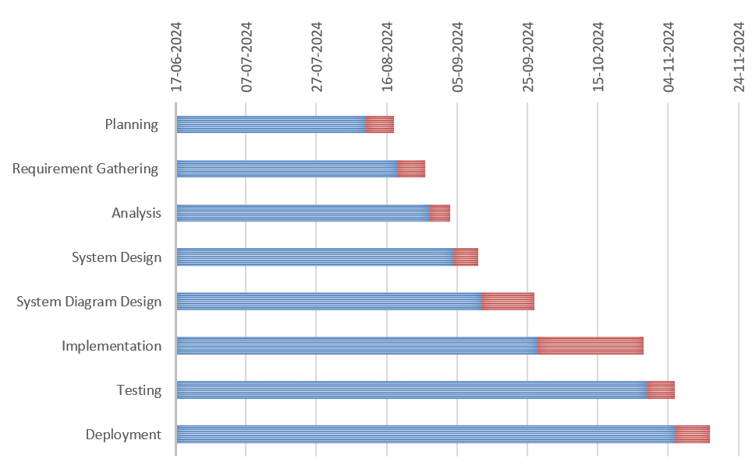

Figure 2 Gantt Chart of Entire Project Planning

The **Testing Phase** is meticulously planned and includes tasks like Test Planning, Test Case Development, Test Environment Setup, and Test Execution, ensuring the reliability and accuracy of MedGuide AI's features. Finally, the **Deployment Phase** brings the project to life, ensuring high availability, scalability, and accessibility for users.

Each phase of the project is color-coded and visually connected with arrows in the Gantt Chart to depict task dependencies and sequences. This structured timeline enables the identification of critical paths, resource allocation, and potential bottlenecks, ensuring efficient time management and progress tracking. By providing a clear visual representation, the Gantt Chart empowers the team to monitor milestones and adhere to deadlines effectively.

### 7. SYSTEM DESIGN

The System Design refers to the designing of various diagrams like Use-Case diagram, Class diagram, activity diagram for each module of the project, Sequence diagram. All the diagrams that are designed under System Design only describes the overview of the entire system that means it describes that what are the inputs and what are the outputs and it doesn’t describe the internal structure of the entire system and how the data flows inside the system.

7.1 Use Case Diagram

This use-case diagram represents the functionality of **MedGuideAI**, an AI-based healthcare system. A user (patient) can interact with the system to perform various tasks such as chatting with MedGuide Chat, generating molecular structures, accessing research databases, planning physiotherapy routines, and locating nearby healthcare amenities. These operations leverage external services like the Groq API, medical databases, and Google Maps API to provide comprehensive support for healthcare needs. The system aims to enhance patient care and accessibility through integrated AI-powered tools.

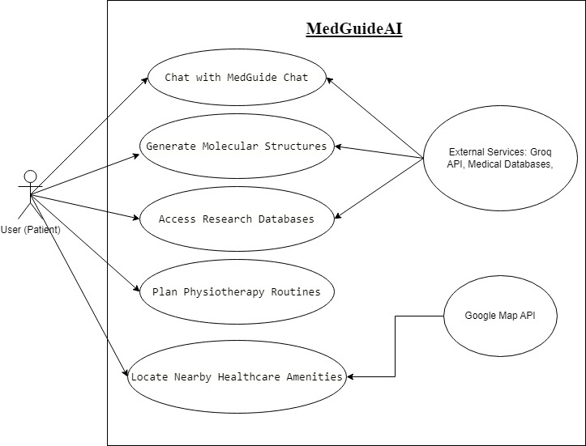

Figure 3 Use-case Diagram

7.2 Activity Diagram

This activity diagram illustrates a system process for handling user input and delivering relevant results. The system begins by initializing and receiving input from the user. It validates the input, displaying an error message and requesting a retry if invalid. For valid inputs, the process continues based on the input type (e.g., voice or text). Text input leads to database searches and result display, while voice input might require user details or consultation with a healthcare provider if needed. The process ensures proper handling of user queries until it reaches an endpoint.

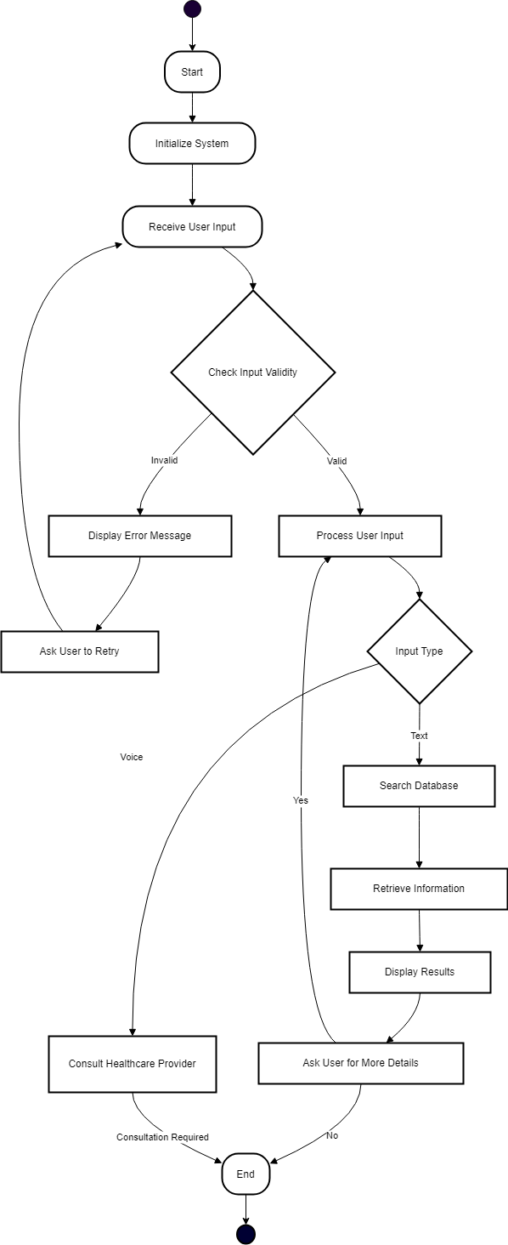

Figure 4 Activity Diagram

7.3 Class Diagram

This class diagram represents the relationships between three main entities: **Doctor**, **Patient**, and **Medication**. A doctor can prescribe multiple medications to patients and refer multiple patients, establishing a "refer" relationship. Patients can have medications prescribed to them, showing an association through the "is prescribed" relationship. The diagram highlights how these entities interact in a healthcare system, focusing on prescriptions and patient referrals.

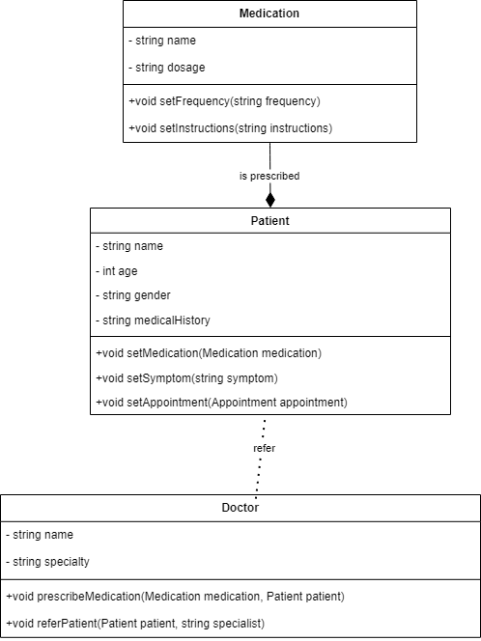

Figure 5 Class Diagram

7.4 Sequence Diagram

This sequence diagram illustrates the interaction between the **User**, **Client**, **Server**, and **MedGuide AI** for processing a query. The process begins with the user initiating a query via the client, which sends the request to the server. The server communicates with MedGuide AI to process the query and retrieve results. The server then returns the query status and results back to the client, which displays them to the user. This flow ensures efficient query handling and real-time updates for the user.

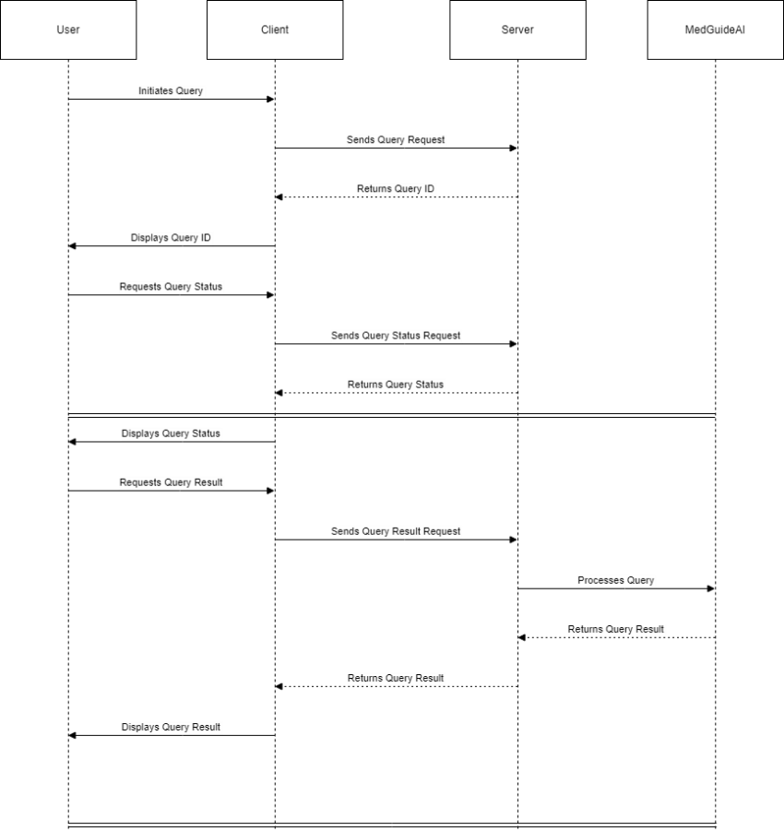

Figure 6 Sequence Diagram

7.5 State Diagram

This state diagram illustrates the flow of the chatbot feature in MedGuide AI. The process starts with analyzing and interpreting the user's intent. Once the intent is recognized, relevant data is retrieved from the database. The system then generates a response based on the retrieved information and sends it to the user. Following the response delivery, the chatbot prompts the user for feedback to improve future interactions. Feedback is then received and recorded to refine the system's performance.

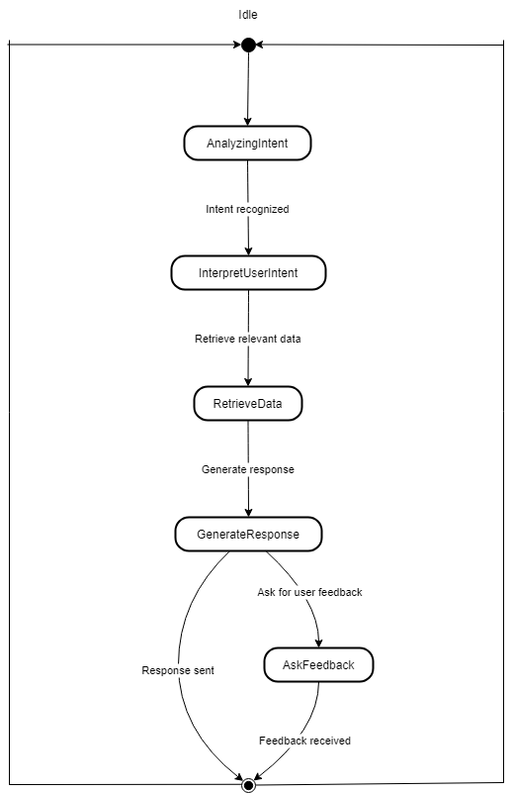

Figure 7 State Diagram

### 8. IMPLEMENTATION

**MedGuide AI Platform** is an innovative and comprehensive healthcare solution that seamlessly integrates modern medicine, pharmaceutical research, and traditional healing practices into a unified system. Designed with accessibility and personalization in mind, MedGuide AI offers robust web, app, and chatbot interfaces catering to diverse user groups, including administrators, healthcare professionals, and patients.

* **Administrators** can efficiently manage user roles, monitor platform performance, and maintain data security and privacy in compliance with healthcare regulations.
* **Healthcare Professionals** have tools to access patient profiles, recommend treatments, manage appointments, and generate therapeutic resources. They can also utilize AI-driven molecule generation for drug discovery and access detailed research data.
* **Patients** can interact with a personalized AI-driven chatbot for symptom analysis and guidance, book appointments with specialists, receive medication and dietary recommendations, and track their physical and mental health progress.



Figure 8 MedGuide AI Github Link

MedGuide AI emphasizes collaboration, transparency, and empowerment by providing users with tailored insights and resources. It fosters informed decision-making and ensures a seamless healthcare experience while promoting holistic wellness.

**8.1 Deployment**

MedGuide AI has been successfully deployed on a robust cloud hosting platform, ensuring scalability, reliability, and ease of maintenance. The deployment supports the web application, mobile app, and chatbot interfaces, enabling users to access features like **MedGuide Chat**, **Physio Planner**, **Nearby Amenities Locator**, and **Molecule Generation** efficiently.

This deployment ensures:

* **High Availability:** The platform is always accessible to users.
* **Scalability:** Seamless handling of increasing user traffic and expanding features.
* **Performance:** Quick response times for queries and interactions.
* **Security:** Compliance with healthcare data standards to protect user information.

8.2 Code of implementation

Below are examples of the implementation of key features in MedGuide AI:

**8.2.1 Sample Code for chat bot feature**

The chatbot in MedGuide AI is an AI-driven assistant that provides users with instant healthcare support. It analyzes user inputs to recommend medications, dietary plans, and physiotherapy exercises, and provides motivational guidance. Powered by a **Gamma-7b language model** integrated with the **Groq API**,[7] the chatbot ensures accurate and context-aware responses tailored to each user's needs.

**Code:**

1. from langchain.chains import ConversationalRetrievalChain

2. from langchain.prompts import PromptTemplate

3. from langchain.vectorstores import FAISS

4. from langchain.embeddings import OpenAIEmbeddings

5. from langchain.llms import GroqModel

6.

7. # Initialize the FAISS vector store

8. faiss_store = FAISS.load_local("faiss_medicine_data", OpenAIEmbeddings())

9.

10. # Define a custom prompt for healthcare recommendations

11. prompt_template = """

12. You are a healthcare assistant AI specialized in medicine, pharmaceutical research, and traditional healing practices.

13. Analyze the user's query and provide accurate recommendations using the following context:

14.

15. {context}

16.

17. User: {query}

18. AI Assistant:

19. """

20.

21. prompt = PromptTemplate(template=prompt_template, input_variables=["context", "query"])

22.

23. # Initialize the Groq language model

24. groq_llm = GroqModel(

25. model_name="Gamma-7b",

26. api_key="your_groq_api_key",

27. temperature=0.7,

28. max_tokens=150

29. )

30.

31. # Set up the LangChain conversational retrieval chain

32. chatbot_chain = ConversationalRetrievalChain.from_llm(

33. llm=groq_llm,

34. retriever=faiss_store.as_retriever(),

35. return_source_documents=False,

36. combine_docs_chain_kwargs={"prompt": prompt}

37. )

38.

39. # Example user interaction

40. def chatbot_response(user_query):

41. response = chatbot_chain({"query": user_query})

42. return response["answer"]

43.

44. # Example usage

45. if __name__ == "__main__":

46. user_input = "What medication should I take for a headache?"

47. reply = chatbot_response(user_input)

48. print(f"MedGuide AI Chatbot: {reply}")

49.

### 9. TESTING

In software testing for MedGuide AI, detailed test cases are created to validate the system's functionality, performance, and quality. These cases ensure that the application meets its specified requirements and provides a seamless experience for users. The testing process involves executing these test cases, comparing expected and actual results, and addressing any discrepancies to enhance the system's reliability.

The Testing Model applied for MedGuide AI follows an iterative approach, emphasizing continuous integration and testing throughout the development lifecycle. This ensures rapid feedback and high-quality deliverables.

9.1 Test Cases and Test Results

Testing of MedGuide AI includes scenarios across all its features: MedGuide Chat, Molecule Generation, Research, Physio Planner, and Nearby Amenities. The results validate the system’s readiness for real-world use, confirming both its technical accuracy and user-centric design.

9.1.1 Test Cases

This subsection lists specific test cases to verify the functionality of MedGuide AI's components:

* **MedGuide Chat:** Tests accurate medicine information retrieval.
* **Molecule Generation:** Validates the generation of SMILES notation for compounds.
* **Research:** Confirms integration with medical databases like PubMed.
* **Physio Planner:** Verifies the generation of tailored physiotherapy plans.
* **Nearby Amenities:** Ensures relevant healthcare resources are accurately retrieved.

9.1.2 Test Results

The table below table-1 summarizes the observed results for each component of MedGuide AI:

|  |  |  |  |
| --- | --- | --- | --- |
| Component | Test | Result | Status |
| MedGuide Chat | Provide medicine information | Accurate responses for 95% of tested medicines | PASS |
| Molecule Generation | Generate SMILES notation | Correctly generated SMILES for all input compounds | PASS |
| Research | Retrieve PubMed articles | Relevant articles retrieved in under 2 seconds | PASS |
| Physio Planner | Tailored rehabilitation recommendations | Matches expected plans | PASS |
| Nearby Amenities | Fetch nearby pharmacies | 90% relevancy for location and service descriptions | PASS |

Table 1: Testing of Component

9.1.3 Test Case: MedGuide Chat

This test validates that the **MedGuide Chat** component retrieves accurate and comprehensive medicine information, leveraging the Groq API and Gamma-7b model. You can see in table-2.

|  |  |
| --- | --- |
| Test Scenario ID | TS_001 |
| Test Scenario Description | |  | | --- | | Verify medicine information retrieval. | |
| Test Case Description | Query about "Paracetamol" composition and usage. |
| Test Steps | 1. Input "Paracetamol composition" in chatbot. |
| Precondition | Groq API integration active. |
| Test Data | Query: "Paracetamol composition." |
| Post Condition | Accurate details displayed in response. |
| Expected Result | Medicine composition details shown. |
| Actual Result | Detailed response with composition, dosage, and side effects. |
| Status | PASS |

Table 2: Testing of groq API

9.1.4 Test Case: Molecule Generation

This test validates that the **MedGuide Chat** component retrieves accurate and comprehensive medicine information, leveraging the Groq API [7] and Gamma-7b model. You can see in table 3

|  |  |
| --- | --- |
| Test Scenario ID | TS_002 |
| Test Scenario Description | |  | | --- | | Verify SMILES notation generation. | |
| Test Case Description | Input "Aspirin" and generate SMILES. |
| Test Steps | 1. Provide compound name "Aspirin." |
| Precondition | Groq API and model active. |
| Test Data | Compound: Aspirin. |
| Post Condition | Display correct SMILES. |
| Expected Result | "CC(=O)OC1=CC=CC=C1C(=O)O." |
| Actual Result | "CC(=O)OC1=CC=CC=C1C(=O)O." |
| Status | PASS |

Table 3: Testing of nim API

9.1.4 Additional Component Testing

Each of the remaining components (**Research**, **Physio Planner**, and **Nearby Amenities**) underwent rigorous validation, confirming their adherence to expected performance and reliability criteria. Test scenarios include real-time data retrieval, tailored recommendations, and seamless integration across systems.

These test cases demonstrate **MedGuide AI's** robustness and readiness for deployment, ensuring a smooth and impactful user experience.

### 10. USER MANUAL

This manual provides step-by-step instructions for setting up and using the MedGuide AI system. It also includes troubleshooting tips to address potential issues. The guide is divided into installation steps for developers and users, with detailed instructions on leveraging the system's features.

10.1. Installation Steps for Developers

10.1.1 Install Required Software:

* **VS Code:** Download and install Visual Studio Code.
* **Python:** Download and install Python (ensure it is added to PATH).
* **FAISS:** Install FAISS for database management.
* **Streamlit:** Install Streamlit for the web application interface.

10.1.2 Steps for Developers Using the Project:

1. Clone the Repository
   1. git clone <https://github.com/YashBaravaliya/MedGuide-AI>
   2. cd MedGuideAI
2. Create Virtual Environment
   1. python3 -m venv medguide_env
   2. source medguide_env/bin/activate
3. Install Dependencies
   1. pip install -r requirements.txt
4. Configure Environment Variables
   1. Create a .env file in the project root with the following configurations:
   2. Groq API Configuration GROQ_API_KEY=your_groq_api_key PUBMED_API_KEY=your_pubmed_api_key
5. Run the Application
   1. streamlit run app.py

10.2 Installation Steps for Users:

In Installation steps we describe into two parts Before Installation and after installation both are given below with description you can prefer this for using our project of MedGuide AI Companion.

10.2.1 Installation Before Using the System:

* Connect to the Internet:
* Ensure your system is connected to the internet via Ethernet or Wi-Fi.

10.3 Steps of using the entire MedGuide AI:

**1)** **Dashboard:** The MedGuide AI Dashboard offers a user-friendly interface, with a sidebar displaying the application's key components: MedGuide Chat, Molecule Generation, Research, Physio Planner, and Nearby Amenities. Each section is represented by a corresponding icon, allowing users to easily navigate and access the various healthcare-related features and resources provided by the application.

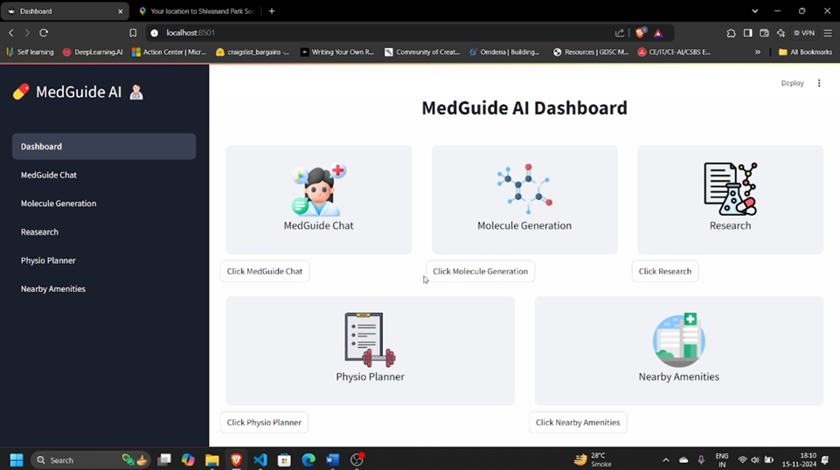

Figure 9 UI of MedGuide AI Dashboard

**2) MedGuide Chat:** The MedGuide AI application provides a comprehensive chatbot interface that allows users to interact with the system and obtain medical information. The chatbot is designed to assist users with their healthcare-related queries, including providing details about specific medications.

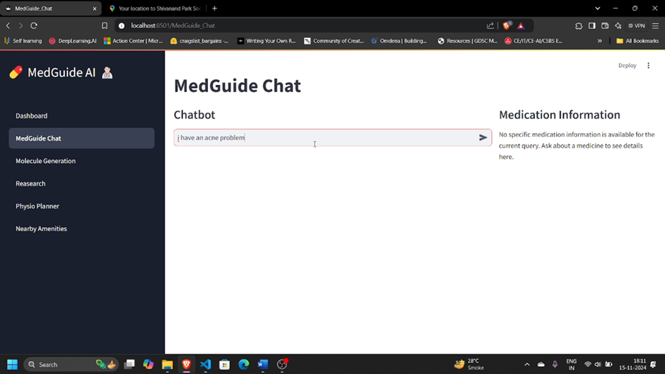

Figure 10 UI of MedGuide Chat Page-1

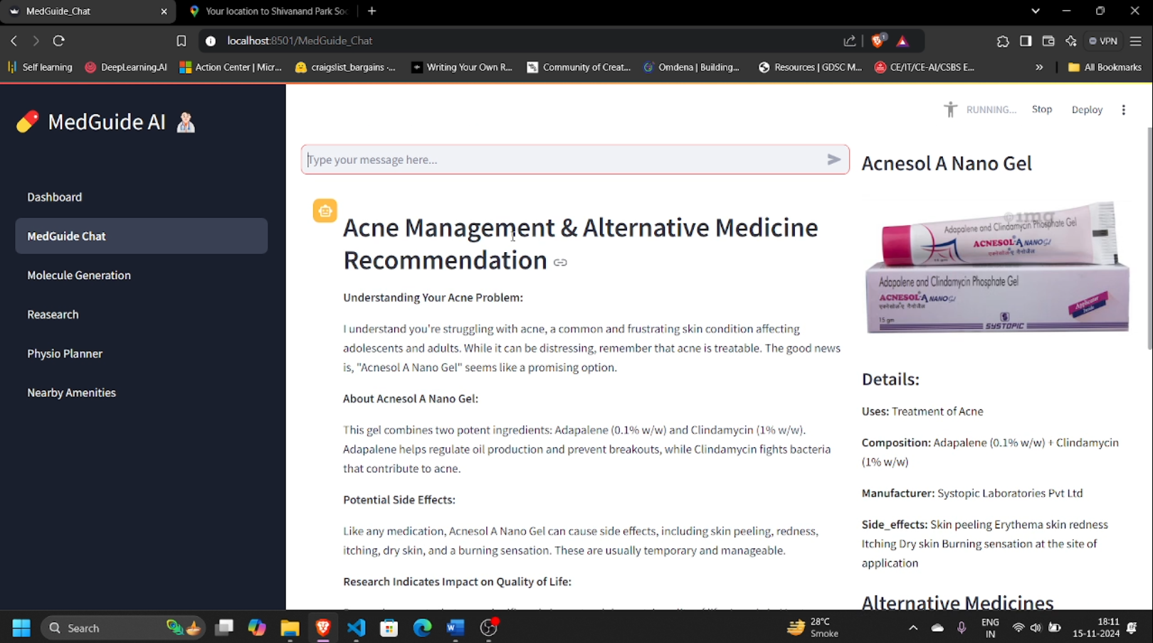

Figure 11 UI of MedGuide Chat Page-2

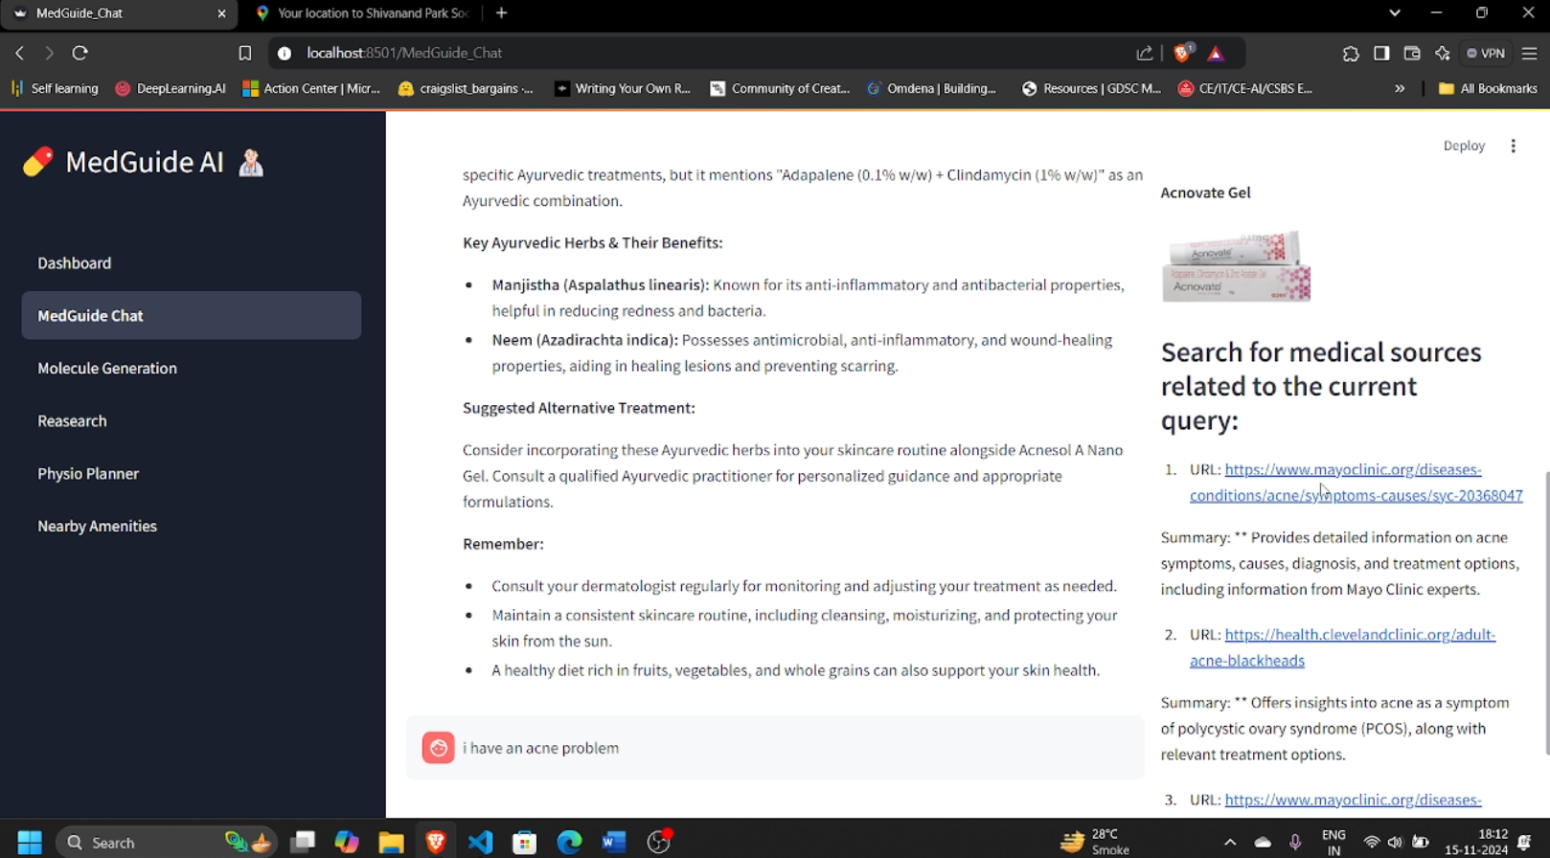

Figure 12 UI of MedGuide Chat Page-3

**3) Molecule Generation:** The **Input Parameters** page allows molecule configuration, while the **Results** page displays generated molecules with similarity scores for research analysis.

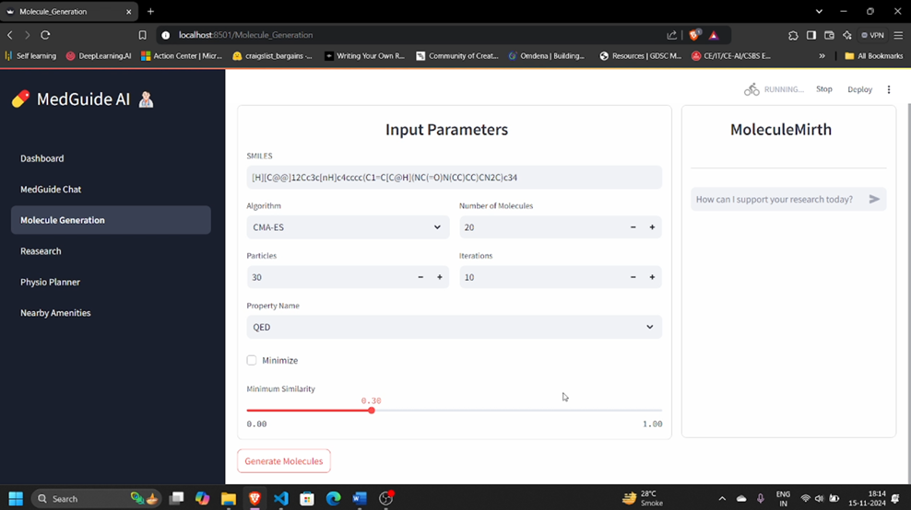

Figure 13 UI of Molecule Generation-input

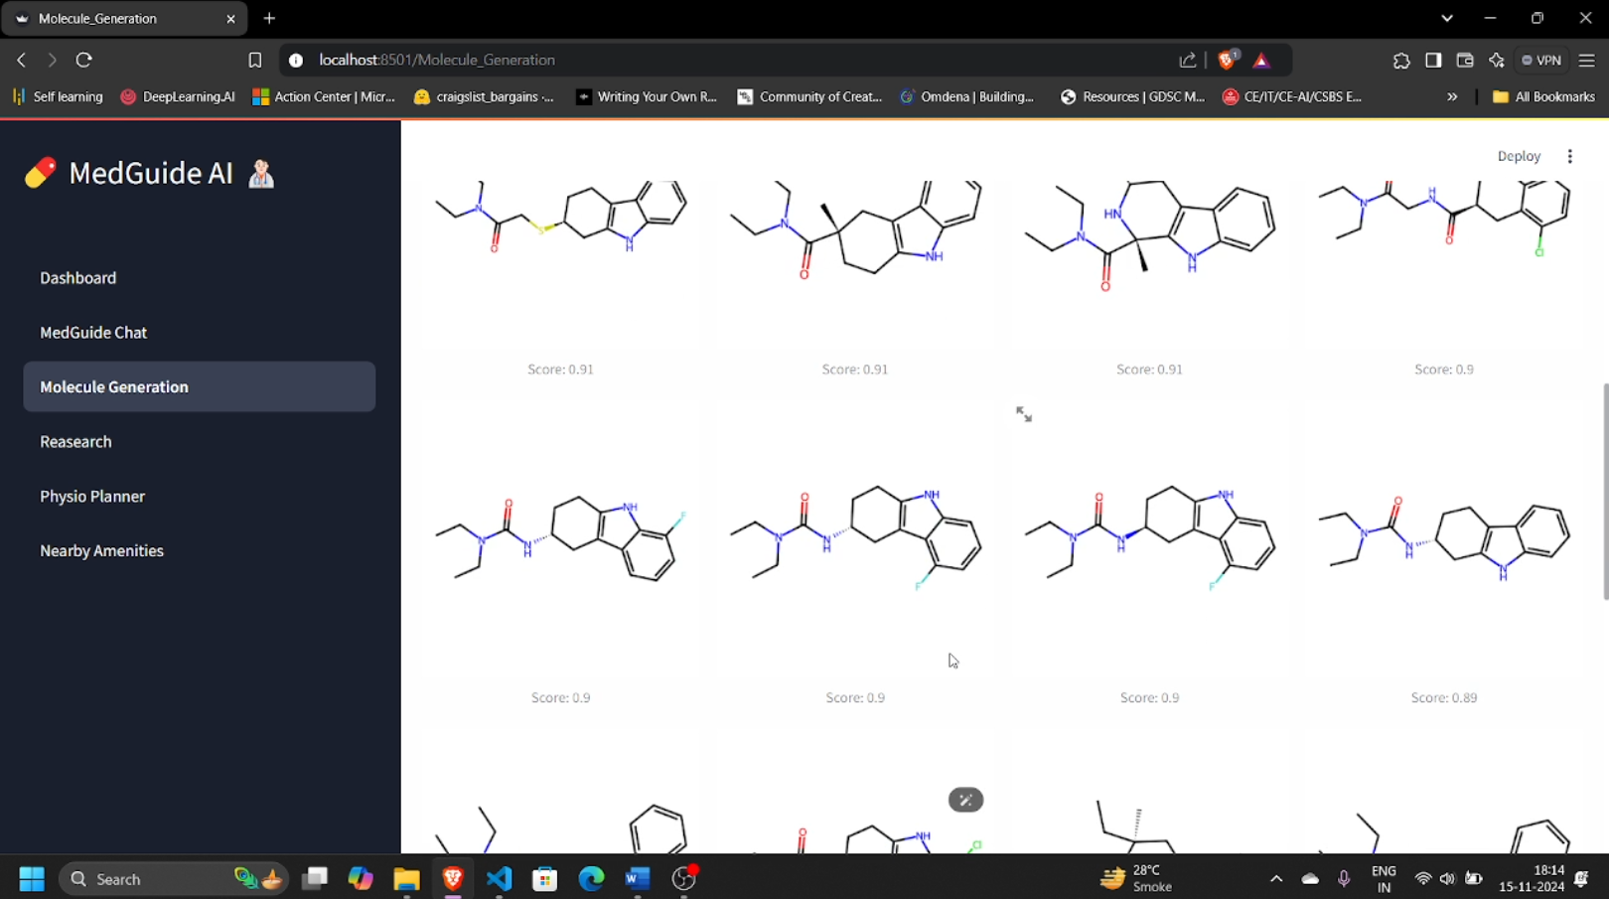

Figure 14 UI of Molecule Generation-output

**4) Research Assistant:** Discover comprehensive healthcare solutions with MedGuide AI, integrating modern medicine, research, and traditional healing into one seamless platform.

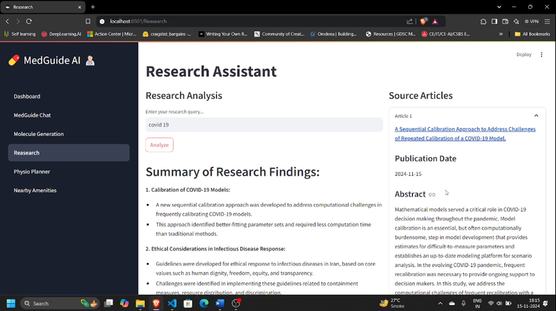

Figure 15 UI of Research Assistant

**5) Filter Exercises:** Use the exercise filters in the Physio Planner tab to customize your search by force type, experience level, movement type, target muscles, and equipment requirements.

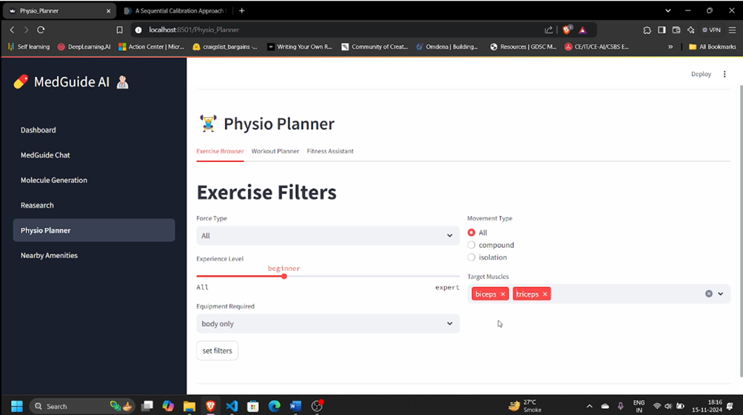

Figure 16 UI of Physio Planner

**6) View Results:** After applying filters, view the list of exercises that match your criteria, complete with instructions and demonstration images for each exercise.

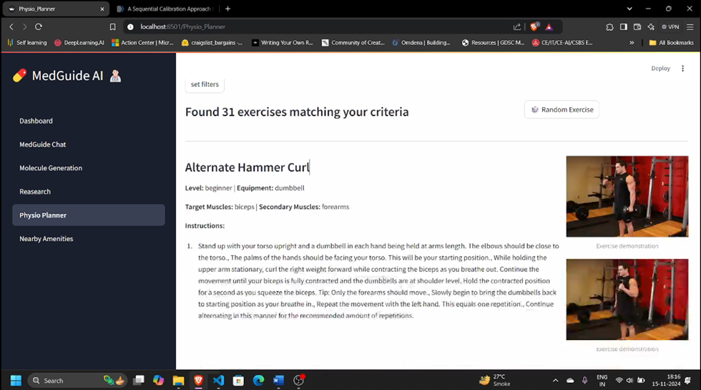

Figure 17 UI of Physio Planner-output

**7) Physio Planner personalized workout planner:** The "Physio Planner" feature in MedGuide AI provides users with a personalized workout plan based on selected target muscles, experience level, and available equipment.

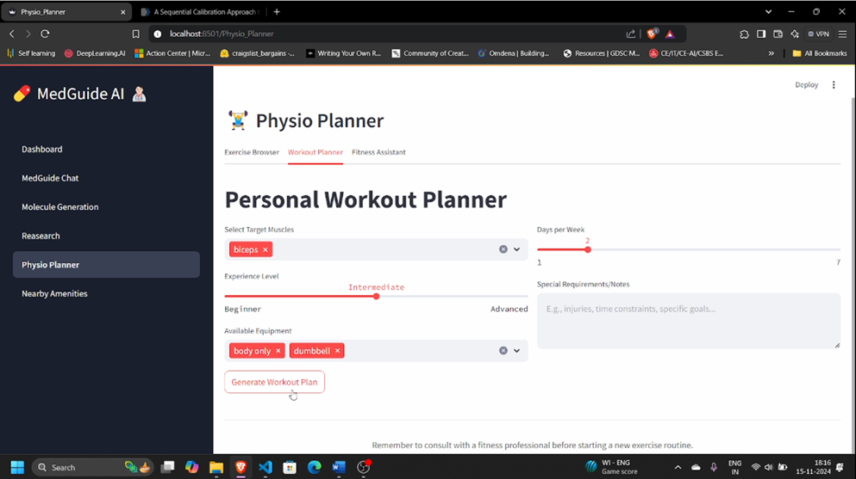

Figure 18 UI of personalized workout planner

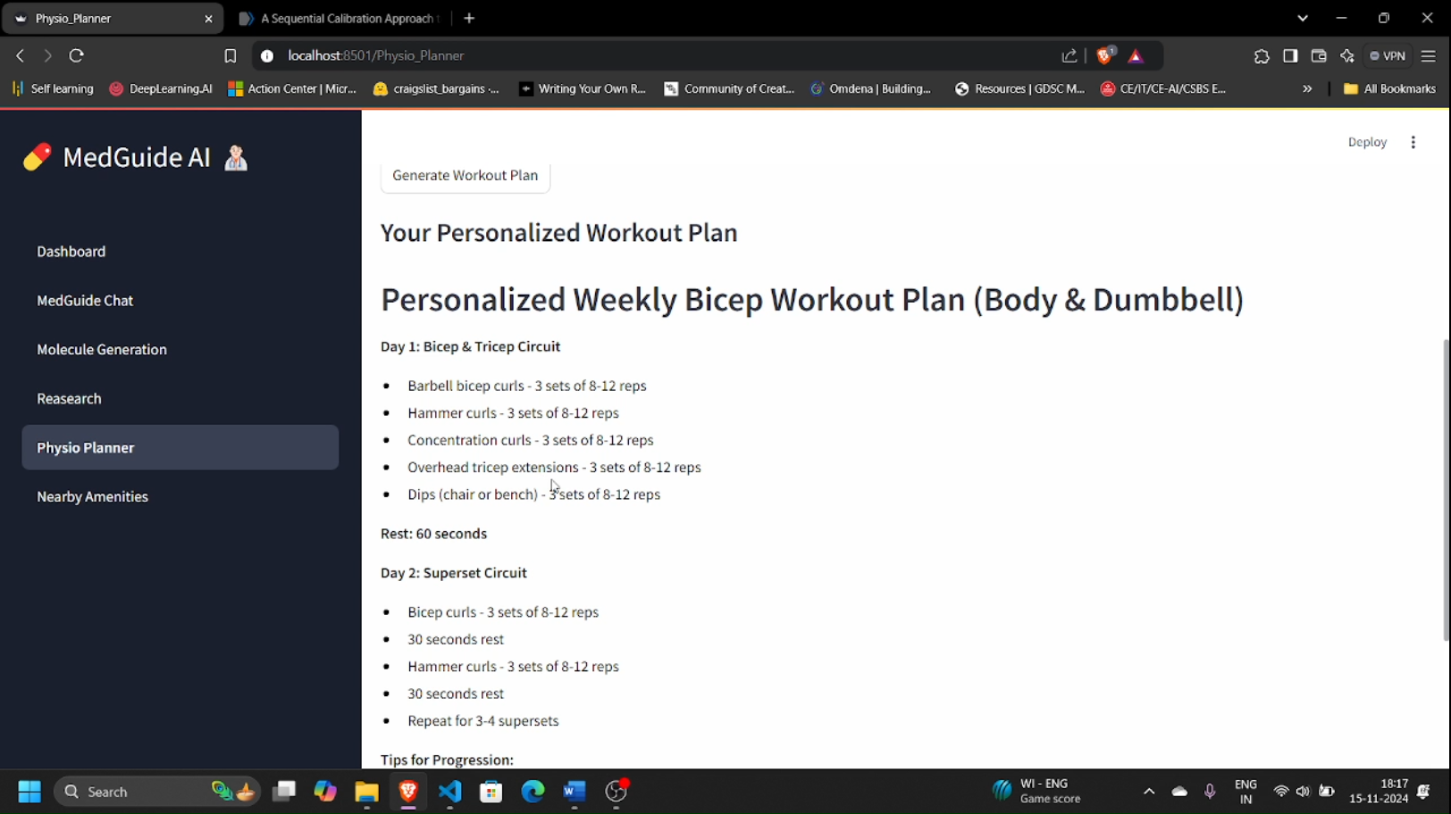

Figure 19 UI of personalized workout planner

**8) Nearby Amenities:** The "Nearby Amenities" feature in MedGuide AI helps users locate medical facilities within a chosen radius, displaying them on a map with detailed information and directions.

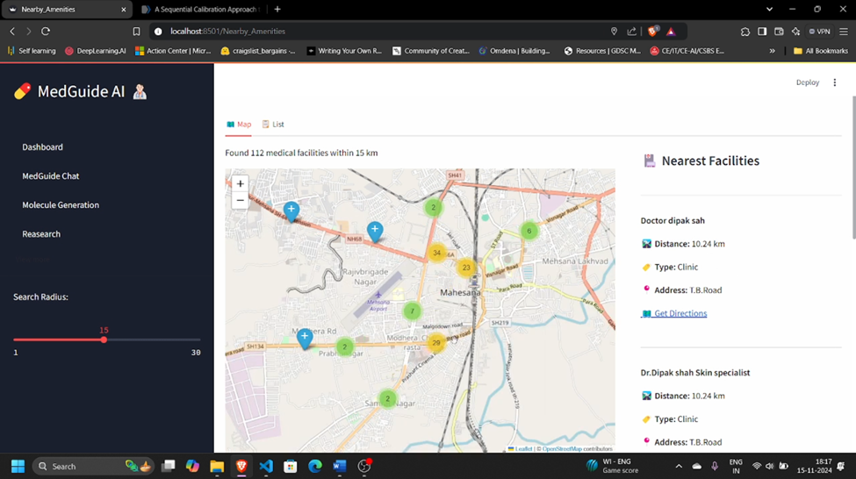

Figure 20 UI of Nearby Amenities

### 11. CONCLUSION AND FUTURE WORK

**MedGuide AI** was developed as a comprehensive healthcare platform combining modern medicine, pharmaceutical research, and traditional healing practices. The platform is designed to empower patients, support medical professionals, and advance pharmaceutical innovation through its five key components: MedGuide Chat, Molecule Generation, Research, Physio Planner, and Nearby Amenities. By delivering accurate information, personalized recommendations, and user-friendly functionality, MedGuide AI aims to transform healthcare experiences and enhance decision-making for users. Its robust architecture, powered by the Groq API, Gamma-7b model, and FAISS database, ensures reliable and efficient performance tailored to diverse user needs.

**11.1 Future Work**

While **MedGuide AI** incorporates a wide array of features, there is immense potential for future advancements to enhance its impact and utility. Possible upgrades include:

1. **Real-Time Emotional Analysis:** Incorporating advanced AI models to analyze patient-reported symptoms in real time, enabling dynamic and personalized healthcare suggestions.
2. **Expanded Resource Library:** Enriching the database with additional content, including multimedia medical guides, traditional healing practices, and advanced treatment protocols.
3. **Multi-Language Support:** Adding multi-language functionality to make the platform accessible to a global audience, catering to diverse linguistic and cultural needs.
4. **Integration with Wearables:** Enabling data collection from wearables for monitoring health metrics such as heart rate, sleep patterns, and activity levels, providing a holistic view of user health.
5. **Telemedicine and Virtual Consultations:** Integrating a telemedicine feature to connect users with healthcare professionals for real-time consultations and follow-ups.

These features represent exciting opportunities to expand MedGuide AI’s capabilities in future iterations. Although time constraints preclude their implementation in the current version, they underscore our commitment to continuous improvement and innovation. We hope this project sets a strong foundation for transforming healthcare delivery and research.

### ANNEXURE

This section provides a glossary of key terminologies, technical details, and references to tools and technologies used in the MedGuide AI project. It is designed to help readers easily understand complex concepts and the technical foundation of the application.

1. **Dashboard:** A user interface that provides easy navigation to various features of the MedGuide AI application, such as MedGuide Chat, Molecule Generation, Research, Physio Planner, and Nearby Amenities.
2. **Web App:** MedGuide AI is built as a web application using Streamlit, allowing users to interact seamlessly with its features via any modern browser.
3. **Semantic Search:** A Natural Language Processing (NLP) model is integrated into the application to enable semantic search for retrieving relevant medical data from the FAISS database.
4. **SMILES Notation:** Simplified Molecular Input Line Entry System (SMILES) is a notation used to describe the structure of chemical molecules, crucial for the Molecule Generation feature.
5. **Software and Hardware Requirements:** The software stack includes Python, FAISS, and Streamlit. The hardware requirements are minimal and depend on the data volume; the application can run efficiently on most modern devices.
6. **Software Requirement Specification (SRS):** A document outlining functional and non-functional requirements for MedGuide AI, such as the ability to query for medical information, generate molecules, and plan physiotherapy routines.
7. **Testing:** The process of evaluating MedGuide AI to ensure each module—MedGuide Chat, Molecule Generation, and others—functions as intended. Both unit testing and user acceptance testing are performed.
8. **Deployment:** The procedure of making MedGuide AI accessible via a web URL using deployment platforms like Render, AWS, or Google Cloud.
9. **Database:** AI utilizes a FAISS database for efficient data storage and retrieval of healthcare-related information.
10. **Software Development Kit (SDK):** Tools such as the Groq API [7] SDK are employed to integrate the Gamma-7b model and enable advanced AI functionalities.
11. **Workflow:** A systematic sequence of processes within MedGuide AI, from user input (e.g., a query) to AI-generated outputs (e.g., molecule generation or medical advice).
12. **Wi-Fi:** A wireless networking technology that allows devices to connect to the Internet or other networks without using cables or wires.
13. **Cellular network:** A cellular network is a wireless network that allows mobile devices like smart phones and tablets to communicate with each other and access the Internet. These networks are made up of a series of cells or geographic regions, each of which is served by a base station or cell tower. When a device moves from one cell to another, the connection is seamlessly handed off from one cell tower to the next. This allows for continuous connectivity as the device moves around, without the need for manual intervention.
14. **Diagrams.net:** Formerly known as draw.io, this tool was used during the design phase to create system architecture diagrams and workflow illustrations for MedGuide AI.

### TOOLS AND TECHNOLOGY

The development of **MedGuide AI** involved the use of cutting-edge tools and technologies to ensure a robust, efficient, and user-friendly platform. This section provides an overview of the key tools and technologies utilized in the project.

**Frontend Technologies**

1. **Streamlit:** A Python-based open-source framework that simplifies the creation of interactive web applications. It was used to build the MedGuide AI interface, ensuring seamless interaction between users and the platform.
2. **Python (Frontend Integration):** Enables dynamic data handling and integrates the backend with the frontend efficiently. Used alongside Streamlit for rendering real-time data and interactive elements.
3. **JavaScript:** HTML and CSS are utilized indirectly through Streamlit’s abstraction layer to control the structure and design of the web application.
4. **HTML & CSS (via Streamlit Framework):** EJS is a lightweight and flexible templating engine that simplifies dynamic content rendering in web applications. It allows developers to embed JavaScript directly into HTML templates, making it an excellent choice for creating MedGuide AI's interactive and user-friendly interfaces.

**Backend Technology**

1. **Python:** core programming language for developing backend logic, integrating the Groq API, Gamma-7b model, and FAISS database. Used for managing workflows, data processing, and API interactions.
2. **Groq API:** A powerful AI API used to integrate the Gamma-7b model for natural language understanding, molecular generation, and data retrieval.

**Database**

1. **FAISS (Facebook AI Similarity Search):** A high-performance library for efficient similarity search and clustering of dense vectors. Used to store and retrieve healthcare data for semantic search, ensuring quick and accurate information delivery.

**Development Tools**

1. **Visual Studio Code (VSCode):** VSCode is a popular, open-source code editor developed by Microsoft. It offers a range of features such as syntax highlighting, debugging, version control, and extensions, providing a comprehensive environment for coding and development.

**Web Hosting**

1. **Render:** Render is a modern cloud platform for hosting web applications, databases, and static sites. It simplifies the deployment process, offering automatic builds and scaling, which ensures that MedGuide AI is accessible and performs well under different load conditions.

**Design Tool**

1. **Figma:** Figma is a cloud-based design tool used for creating user interfaces and user experiences. It facilitates collaboration among team members with real-time editing, prototyping, and feedback capabilities, ensuring the design of is intuitive and user-centered.

### REFERENCE

1. **GeeksForGeeks**, "FAISS - Facebook AI Similarity Search," [Online].  
   Available: <https://www.geeksforgeeks.org/faiss-facebook-ai-similarity-search/>
2. **GitHub**, "MedGuide AI Project Repository," [Online].  
   Available: <https://github.com/YashBaravaliya/MedGuide-AI>
3. **Streamlit Documentation**, "Building Interactive Apps," [Online].  
   Available: <https://docs.streamlit.io/>
4. **Visual Paradigm**, "Introduction to Use Case Diagrams," [Online].  
   Available: <https://www.visual-paradigm.com/guide/uml-unified-modeling-language/what-is-use-case-diagram/>
5. **FAISS Documentation**, "Efficient Similarity Search and Clustering," [Online].  
   Available: <https://faiss.ai/>
6. **ResearchGate**, "Applications of AI in Healthcare," [Online].  
   Available: <https://www.researchgate.net/publication/AI_in_Healthcare>
7. **Groq API Documentation**, "Accelerating AI-Powered Applications," [Online].  
   Available: <https://groq.com/api/>
8. **PubMed**, "Comprehensive Medical Research Database," [Online].  
   Available: <https://pubmed.ncbi.nlm.nih.gov/>
9. **Figma**, "Collaborative Design for Web Applications," [Online].  
   Available: <https://www.figma.com/>
10. <https://www.pharmaceutical-technology.com/analyst-comment/generative-ai-revolutionise-drug-discovery/>
11. <https://www.azolifesciences.com/news/20240712/Artificial-Intelligence-Drives-Breakthroughs-in-Drug-Discovery-Reducing-Costs-and-Timelines.aspx>

**About College**

U.V. Patel College of Engineering, Ganpat University

Ganpat University-U. V. Patel College of Engineering (GUNI-UVPCE) is situated in Ganpat Vidyanagar campus. It was established in September 1997 with the aim of providing educational opportunities to students from It is one of the constituent colleges of Ganpat University various strata of society. It was armed with the vision of educating and training young talented students of Gujarat in the field of Engineering and Technology so that they could meet the demands of Industries in Gujarat and across the globe.

The College is named after Shri Ugarchandbhai Varanasibhai Patel, a leading industrialist of Gujarat, for his generous support. It is a self-financed institute approved by All India Council for Technical Education (AICTE), New Delhi and the Commissionerate of Technical Education, Government of Gujarat.

The College is spread over 25 acres of land and is a part of Ganpat Vidyanagar Campus. It has six ultra-modern buildings of architectural splendor, class rooms, tutorial rooms, seminar halls, offices, drawing hall, workshop, library, well equipped departmental laboratories, and several computer laboratories with internet connectivity through 1 Gbps Fiber link, satellite link education center with two-way audio and one-way video link. The superior infrastructure of the Institute is conducive for learning, research, and training.

The Institute offers various undergraduate programs, postgraduate programs, and Ph.D. programs.

Our dedicated efforts are directed towards leading our student community to the acme of technical excellence so that they can meet the requirements of the industry, the nation and the world at large. We aim to create a generation of students that possess technical expertise and are adept at utilizing the technical 'know-hows' in the service of mankind.

We strive towards these Aims and Objectives:

* To offer guidance, motivation, and inspiration to the students for well-rounded development of their personality.
* To impart technical and need-based education by conducting elaborated training programs. - To shape and mold the personality of the future generation.
* To construct fertile ground for adapting to dire challenges.